{build} 2026 Product Write-up
As we approach the final stretch of {build} 2026, we'd like you to share the story of your project. Please submit a Product Write-up to be published at build.tech.gov.sg/projects! This is your chance to articulate the problem you've tackled and the solution you've engineered. We hope that this will help inspire future batches of {build}ers even after the conclusion of {build} 2026.

Submission Instructions
- Initial Write-up Deadline: End of Week 4 (10 May).
- Action: Go to your team’s page at build.tech.gov.sg/teams and update the team submission with reference to the guideline below, aiming to be clear and succinct.
  - You may include visuals throughout the write-up if desired.
*You may refer to go.gov.sg/product-one-pager (on COMET/GSIB) by PMP for more details.

Product Writeup Guideline

0. The Basics
- Product Name
  - HustleSG
- Product One-liner (< 150 words)
  - A government-adjacent gig economy platform for Singapore that connects workers and requestors through verified identities, credential checks, and secure payments — making gig work trustworthy for everyone.
- Team Members & Respective Divisions
  - Development:
    - Darren Chua (CIOO)
    - Dhanushka Chandika Perera (CIOO)
  - Designer:
    - Evelyn Chong (CMG)
  - PM/market research:
    - Marcus Ling (SAIS)
    - Zhi Sheng Kerk (GPE)
- Cover Image: A high-quality visual to represent your project on the site.
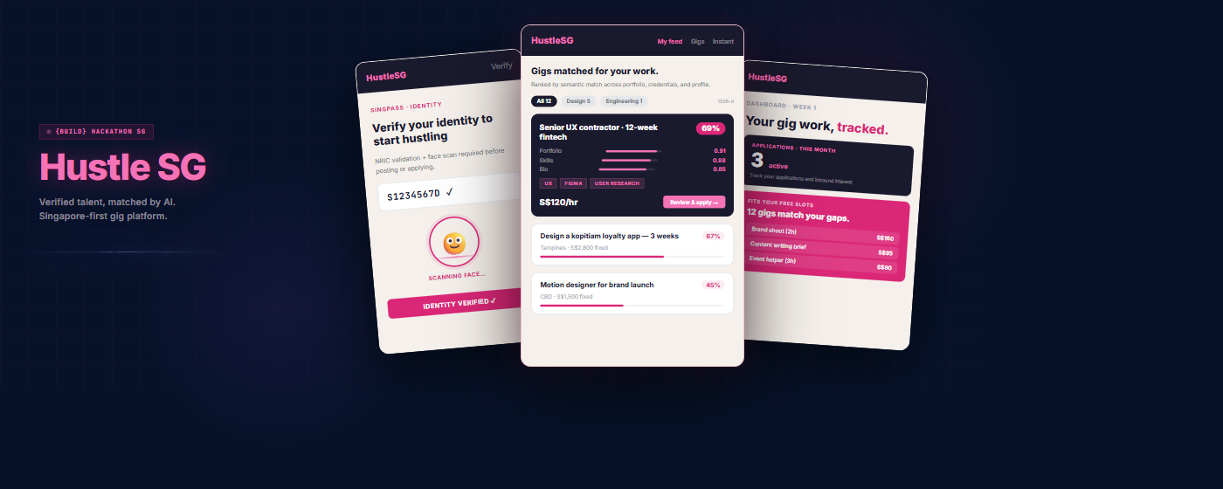

1. Problem Statement
- Users: Who are the people affected? Include the size/quantity of users affected if possible.
The primary users are Singapore-based gig workers (freelancers, side-hustlers, students looking for jobs) and requestors (individuals and SMEs seeking services, Government services looking for event staff). The affected population spans students, National Servicemen, Gen-Z professionals pivoting to blue-collar trades, and mid-career workers displaced by AI automation. Singapore's resident workforce numbers ~2.3 million, with gig and self-employed workers estimated at over 200,000 and growing — especially as Gen-Z increasingly opts for blue-collar and trade-based roles.
- Use Case: What are they trying to do and what task are they trying to complete? Where and when do they encounter this problem?
Workers are trying to market their services, demonstrate verified skills, and get paid reliably. Requestors are trying to discover, vet, and safely hire freelancers for specific tasks. Both groups encounter this problem on existing generalist platforms (Carousell, Facebook Marketplace, Fiverr) where discovery is unstructured, and trust signals are largely absent. These interactions happen in both daily consumer contexts (home services, tutoring) and SME contexts (logistics, events, F&B).
- Pain Point: What is the possible root cause behind the problem you have observed?
The root cause is a trust infrastructure gap. Singapore has no centralised, government-adjacent platform for gig work. Without SingPass-linked identity, verified credentials, or escrow-backed payments, both sides bear the full risk of every transaction. Workers cannot credibly prove their skills; requestors cannot safely pay without risk of fraud or non-delivery. This is compounded by "market-spoiling" behaviour — fake agencies, low-balling, and scam listings degrade overall platform quality on open marketplaces.
- Consequence: What happens if we don't solve the problem? Size your consequence based on the magnitude of effect on your users.
If unsolved, high-value professionals and skilled tradespeople will continue to avoid gig platforms, limiting supply quality. Requestors will resort to informal referrals or expensive agencies. As AI accelerates workforce displacement, displaced workers will have no structured channel to monetise adjacent skills. Singapore risks missing the opportunity to formalise and protect a growing informal labour market — one that, without structure, could become economically and socially destabilising.

2. User Research and Market Analysis
- User Research: What user research methods did you adopt to validate that this solution is needed and what were the key insights from real users?
We conducted a survey of 500 respondents across worker, requestor, and dual-role segments. Key insights:
- Trust is the #1 priority: 87% of respondents rated trust and verification a 4 or 5 out of 5 in importance — making it the single most demanded capability across all user types.
- Matching is broken: 53% rated finding the right match as difficult (4 or 5 out of 5), signalling that existing platforms fail on discovery.
- Top frustrations (multi-select): "Hard to know who is trustworthy" (313 respondents), "Scams/fake listings" (281), and "Hard to prove skills/quality" (259) dominated — far ahead of pricing issues or time costs.
- Most trusted signals: Verified identity (303), verified skills/certifications (273), and work history/completed jobs (268) were the top three trust drivers.
- Most wanted features: Better skill/location/availability matching (344), verified profiles (333), and fraud/scam protection (272) were the top three desired features.
- Verification appetite is high: 91% said "Yes" or "Maybe" to completing verification steps if it helps them win more jobs or safer hires — with only 8.8% saying No outright.
- Qualitative highlights from open-text responses: Users explicitly requested Singpass login ("Login via Singpass", "Gahmen endorsement and audit"), human dispute agents over bots ("Have actual people as customer service agents. Not some bullshit bot."), and a platform that can "sieve out degree mill holders" and "fake marketing agencies."
- De-risking: What market risks are there and how did you mitigate them?

Risk | Mitigation
Low adoption due to verification friction | Phased onboarding — Singpass badge unlocks premium features; not mandatory for basic browsing
Cold-start supply-demand imbalance | Target dual-role users first (37.6% of respondents) — they simultaneously supply and demand, reducing CAC on both sides
Competition from incumbent platforms | Differentiate via government-linked trust rails (SingPass, WSQ, ACRA) that no private platform can replicate
Worker resistance to tax/ACRA integration | Position as optional value-add ("grow your side hustle into a business"), not mandatory compliance overhead

- Stakeholder Buy-in: Which agencies or departments did you reach out to and did they express interest or commitment?
The product roadmap is designed around integration with GovTech (Singpass), SkillsFuture Singapore (WSQ credential verification), ACRA (sole-proprietor registration), IRAS (automated gig income tracking),MOM (labour policy alignment), and WSG (Competitive Singapore Workforce). We have yet to reach out to the agencies / departments

3. Solutioning
- Problem-Solution Fit: How does your product specifically address the pain points identified?

Pain Point (from survey) | Solution
Hard to know who is trustworthy (313 respondents) | Mandatory Singpass login eliminates anonymous bad actors
Scams/fake listings (281 respondents) | Tiered verification: Singpass identity + WSQ/university credential audit + ACRA business registration check
Hard to prove skills/quality (259 respondents) | Portfolio page with video demos, work samples, verified credential badges
Better matching needed (344 respondents) | AI-powered discovery engine matching on skill, location, and real-time availability
Unclear pricing/scope creep (195 respondents) | Automated contract templates + milestone-based escrow payment release
Payment risk (135 respondents) | Escrow holds funds at project start; released only on delivery
Disputes hard to resolve (116 respondents) | Human-mediated dispute channel with transparent evidence submission workflow

- Functionality: What are your key user flows/features?
  - SingPass onboarding — verified identity in one step; profile pre-populated with government records
  - Portfolio builder — short-form video demos, website links, and work sample uploads tied to the profile
  - Credential verification — link WSQ cert IDs, university records, or ACRA registration for a verified badge
  - Video interview — pre-hire in-platform video capability before commitment
  - AI-powered matching — requestors browse or get matched to workers by skill, location, availability, and verified rating history
  - Escrow payments — funds held at project start, released on milestone completion
  - Dispute channel — in-app flagging with human agent escalation (not bots)
  - Re-hire & ratings — verified reviews build social proof and feed the recommendation algorithm
- User Experience: How did you make the experience seamless/intuitive for the end user?
The platform is designed around progressive trust — new users can browse listings immediately without mandatory verification, while completing verification unlocks premium placement, escrow access, and the verified badge. A "Junior Match" tier onboards new workers safely with moderated pricing and mandatory escrow for their first five jobs, addressing the "new player paradox" surfaced in survey responses. Dual-role users can seamlessly switch between worker and requestor mode within the same session. The interface is mobile-first and designed for users who are not highly tech-savvy, reflecting survey feedback emphasising "easy to use," "simple interface," and "not laggy."
- User Validation: What feedback did users give about the product? What worked well and what required improvement?
Survey open-text feedback strongly validated the core product direction:
- Trust, verification, and scam protection were the most cited "must-do-well" themes
- Users explicitly requested human dispute agents, Singpass login, and the ability to "sieve out fake profiles and marketing agencies"
- Areas flagged for improvement: onboarding must not feel bureaucratic, verification must be asynchronous (users should not have to wait), and the platform must maintain a large enough user base to be viable ("must have critical mass")

4. Impact & Next Steps
- Success Metrics: What is your "North Star" metric?
Verified Transaction Completion Rate — the percentage of job requests that result in a completed, escrow-released, reviewed transaction between two verified users. This single metric captures platform health across trust, matching quality, and financial integrity simultaneously.
- Expected Impact: What outcomes do you expect this to be able to deliver in the short/medium/long term if your product is launched to users?
Horizon | Expected Outcome
Short-term (0–6 months) | Pilot cohort of dual-role users establishes verified listings; Singpass integration live; baseline NPS and re-hire rates benchmarked
Medium-term (6–18 months) | Measurable shift in user-reported sentiment from "high-risk marketplace" to "verified utility"; escrow adoption drives retention; credential verification reduces scam-related churn
Long-term (18+ months) | HustleSG becomes the de facto trust layer for Singapore's gig economy; ACRA integration enables platform alumni to formalise their businesses; IRAS integration reduces tax friction for 200,000+ self-employed workers; platform data informs MOM workforce policy
Supporting metrics to track alongside the North Star:
- Re-hire rate (signals worker quality and platform stickiness)
- Dispute resolution time and resolution satisfaction score
- Verified profile completion rate (% of users with Singpass + at least one credential badge)
- NPS segmented by workers vs. requestors
- Monthly Active Dual-Role Users (proxy for network liquidity health)

Closing Statement
HustleSG is built to strengthen Singapore’s future workforce in an era of AI disruption and rapidly changing work patterns.
By combining trusted identity verification, credential-backed hiring, and secure payments, HustleSG transforms gig work from an informal, high-risk marketplace into a trusted economic ecosystem.
As more Singaporeans turn to freelancing, side hustles, and skills-based work, HustleSG provides the infrastructure for workers to earn safely, build credibility, and grow sustainably — while giving requestors confidence in who they hire.
Beyond solving today’s trust and matching problems, HustleSG lays the foundation for a more resilient, adaptive, and inclusive workforce for Singapore’s future.

